HEAD-ON NIGHT VISION DEVICES
Viktor VOLKOV
For special operations requires effective night vision devices (NVD) [1]. They provide surveillance at dusk, at night, and in some cases - also at a reduced atmospheric transparency (haze, fog, rain, snow, etc.). At the same time, there are occasions when the operator's hands should be free (for example, rescue operations, anti-terrorist actions, in landing, if necessary, driving and so on). To fulfill this condition NVD should be set at the head of the operator. It is possible the execution head-on hands free NVD in the form:
- - night vision goggles;
- - low-level television system (NTVS);
- - thermal imaging device;
- - helmet-mounted combination unit.
Night vision goggles as hand-on NVD historically appeared before all. In this distinguished and single II Tube binocular night vision goggles [1]. Binocular glasses consist of two identical channels of night under the right and left eyes of the operator (photo 1).
Each channel consists of a lens 1, an electron-optical converter (EOC) 2 [2] and the eyepiece 3 (Fig. 1). In the glasses ensures smooth adjustment of the distance between the pupils of the eyes (eye base) within 52 - 72 mm.
In some models, there is no such regulation and the ability to monitor operators with different bases of the eye is ensured by the large exit pupil diameter eyepieces is 12 - 13 mm [3], while the maximum diameter of the pupil of the eye does not exceed 8 mm. In the glasses of all types of dioptric focusing eyepieces provided within ± 5 diopters, sometimes (2) - (-6) diopters and refocusing lenses with the best view of the final distance (0.25 m) to infinity. Such refocusing is necessary to monitor both remote and nearby objects (such as maps of the area, repair tools, dashboard).
The main parameters of the typical binocular night vision goggles are shown in Table. 1. They are often made ​​on the basis of generations of image intensifier II +, II ++, III, and in recent years in the USA - and IV [4, 5].
Power Points provided by the standard of the primary power source: two AA batteries to power 2.5 - 3 V DC, in some cases, from one AA battery voltage of 1.5 V. The batteries based on their capacity allows continuous operation of 8 points to 40 hours. Points attached to a face mask, which in turn is mounted on the head via a headband with an adjustable belt size. Binocular glasses provide a stereoscopic effect, which is useful for driving traffic. In this connection it should stay on the variety of devices - NVD for the pilot [1, 3, 6 - 8] (Figure 2A).
The distinctive feature of these glasses is that they do not mount to the face mask, and a pilot's helmet (photo 2b). The design of points provides adjustment of their position with respect to the face of the operator within all six degrees of freedom. In order to design the bailout of the mount points allows for their rapid drop. In addition, the possibility of tipping points from the operating position outside. Points for the pilot are built as a standalone primary source of power, as in conventional night vision goggles and powered by the board circuit aircraft.
To ensure balancing masses on the rear surface of the pilot's helmet is secured counterweight. The pilot in goggles should observe how under cabin space and dashboard. However, its glowing lights produce excessive light load for points. Therefore put on the special glasses lenses interference filters "minus blue" ("minus blue"), cutting off part of the visible light.
This combined with the organization of the optimal range of cabin lighting allows you to monitor through the glasses as a under cabin space and dashboard. However, to observe points in this space objectives should be focused on infinity, and to monitor the dashboard - a finite distance. Since the refocusing lenses during the flight control is not possible, the glasses have a large eye relief eyepieces - more than 20 mm. This allows the pilot, squinting, watching the dashboard, avoiding nighttime feeds.
.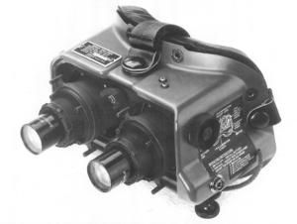
Photo 1. Appearance of typical binocular night vision goggles
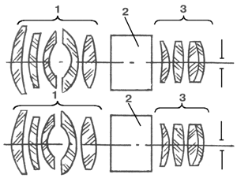
Fig. 1. Optical scheme binocular night vision goggles
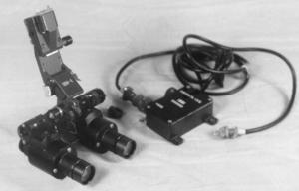
а)
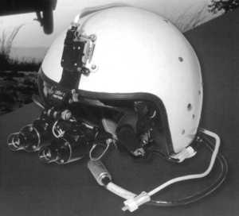
б)
Photo 2. Exterior typical binocular aviation night vision goggles (a), the same pilot's helmet (b).илота (б).
Table 1. Basic parameters of typical binocular night vision goggles
It's not very convenient, so the firm GEC Avionics (UK) has developed glasses Cats Eyes with ocular prism system [9]. Appearance points given in picture 3, and their optical scheme - Fig. 2, where 1 - the lens 2 - GO, 3 - prismatic eyepiece system.
It has a curved prism hypotenuse surface of the dichroic coating is reflected in the spectral region of the screen image converter (yellow-green spectrum) and transmitting visible light from the instrument panel and the interior of the cabin. As a result, the pilot sees under cabin space and dash at the same time. A variation of these points is the model of the firm Marconi Avionics Ltd. (United Kingdom).
Their appearance is shown in Fig. 3a and optical scheme - Fig. 3b [10]. This simultaneous observation of the night, and the visual image is called "cross-cutting vision" ("see-through"). These points have also small longitudinal dimensions. This allows you to take them to the so-called "low profile" ("low profile") night vision glasses (See below.).
The company has also developed sunglasses for the pilot scheme which is shown in Fig. 4. Mirror 3 dichroic coating provides a "through-vision". [11] In order to increase the plasticity of points and, respectively, to increase their range of stereoscopic vision company ITT (USA) has developed glasses Merlin [12]. The main parameters of typical aviation night vision goggles are given in the Table. 2.
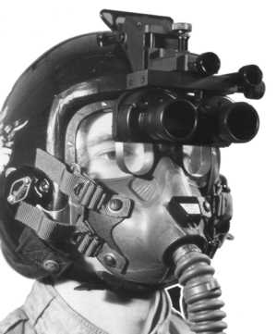
Photo 3. Exterior view of night vision goggles Cats Eyes
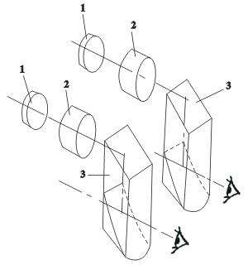
Fig. 2. The optical scheme of night vision goggles Cats Eyes
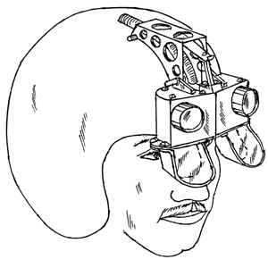
а)
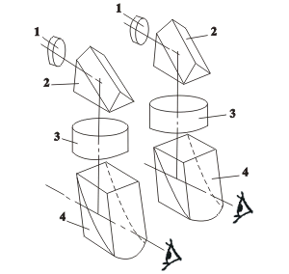
б)
Fig. 3. The appearance of night-vision goggles [9] (a) and optical circuit (b) where 1 - the lens, 2 - with a roof prism, 3 - GO, 4 - ocular prism system
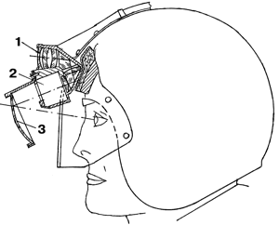
Fig. 4. Scheme aviation night vision goggles firm Marconi Avionics Ltd., where 1 - lens prisms 2 - GO, 3 - ocular dichroic mirror.
Table 2. Main parameters of aviation night vision goggles.
A common drawback of glasses for the pilot is their limited field of view. To increase it in the horizontal direction in some binocular goggles practiced breeding side of the optical axes of the individual channels [11]. Thus the total field of view of the horizon reached 40 0 at an angle of field of view of the individual channels 25 0. However, these glasses cause eye fatigue.
In addition, many people do not have sufficient convergence eye - the ability to breed them in the optical axis directions. For a radical increase in the angle field of view company ITT (USA) developed the so-called panoramic night vision goggles PNVG (Panoramic Night Vision Goggle) [13 - 18]. Option points PNVG-1 is made ​​on the basis of four specially designed by EOC without turning the image photocathode diameter 16 mm and a weight of 22 g [17].
Points have a field of view of the horizon 100 0 and vertical - 40 0. Fig. 5a shows the appearance of points PNVG-1 in Fig. 5B - same points mounted on the pilot's helmet in comparison with conventional glasses (shown in phantom). Fig. 5c given optical circuit of two central points nighttime channels [18], which is a low-profile basis points AN / PVS-21 [14]. By ITT has also developed a model PNVG-2 [13 - 18].
It is characterized by extreme simplicity, though not a low profile. The device (Fig. 6a) consists of four night-channel as shown in Fig. 6b, in which 1 - Lens 2 - GO, 3 - eyepiece. The optical axes of the two central channels of mutually parallel axes and two side channels separated the sides at an angle of 10 0 each. These glasses used image intensifier the same company, but with the rotation of the image. With a diameter of 16 mm Weight photocathode image intensifier is 51, the total mass of the device reaches 750 This binocular vision is maintained within the field of view angle 30 0. The right and left eyes separately cover the field of view angle 40 0. To monitor the peripheral areas of the visual fields the operator takes the pupils of the eyes, respectively, left or right. The field of view is observed at the same time without breaks. Its appearance is shown in Fig. 7. It shows the field of vision of a miniature thermal imaging channel, combined with glasses [15]. This channel gives the enlarged image of the object.
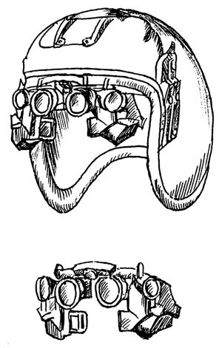
а)
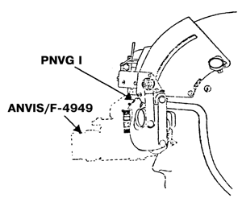
б)
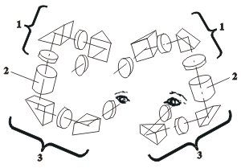
в)
Fig. 5. Appearance of night vision goggles PNVG 1 (a), their helmet arrangement (b) compared with conventional glasses ANVIS (F 4949) (dotted line), optical circuit points PNVG 1 night for two channels (c), where 1 - Lens 2 - GO, 3 - ocular system
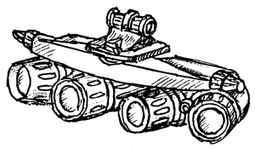
а)
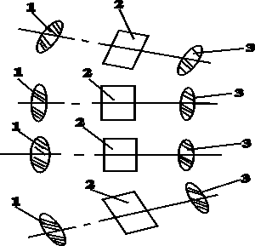
а)
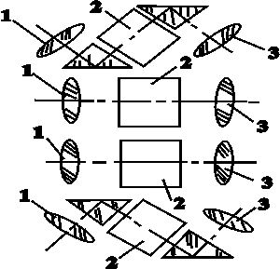
а)
Fig. 6. The appearance of night-vision goggles PNVG 2 (a) and options for their optical circuits (b, c)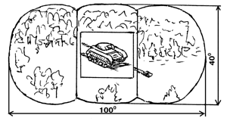
Fig. 7. The appearance of the visual field of night vision goggles PNVG; is shown in the center of the additional image from the built-in small-sized thermal channel
The desire to provide a "through-vision" has also led to the creation of so-called "holographic" of night vision goggles. Their name is not associated with the method of creating the image, and with the same manufacturing techniques of the mirrors, as for holographic optical elements. The company OIP (Belgium) developed a binocular glasses HNV-3D [6, 19] (photo 4), their optical scheme is shown in Fig. 8, where 1 - the lens 2 - GO, 3 - "holographic" Mirror, 4 - ocular system.
The central part of the image points takes the night with a field of view 40 0 and the peripheral part of - day image with a viewing angle of 0 to 100. These points are the low-profile. The dichroic mirror 4 reflects the coating in the emission spectrum of the screen image converter and passes the rest of the visible spectrum. The operator sees the image of the scene at the same time and through the night channel points, and an image of the same scene, passing GO. This allows continuous monitoring under the influence of light interference when the night channel becomes inoperative. "Through the vision" and provide night vision goggles AN / AVS-502 [31] (photo 5). Their night view of 0 to 40 with a total angle of sight 100h90 0. The device can be combined with head-on display pilot. With this in view can be incorporated thermal image channel or service information.
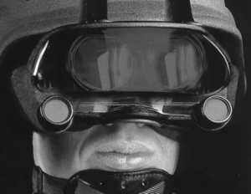
Photo 4. Appearance "holographic" NVG HNV-3D
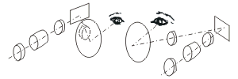
Fig. 8. The optical scheme "holographic" NVG HNV-3D
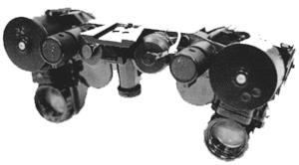
Photo 5. The appearance of night-vision goggles AN / AVS-502
Night vision goggles can also be complemented by a compact communications system based on semiconductor laser [20], developed by Philips (Netherlands) (photo 6). The transmitter is built into the glasses, the lens has a variable focal length for the operation of the laser beam as a narrow (for communication) and wide beam (for illumination). The communication range of 1 - 2 km at a supply voltage 9 and uptime of the communication system for 4 hours.
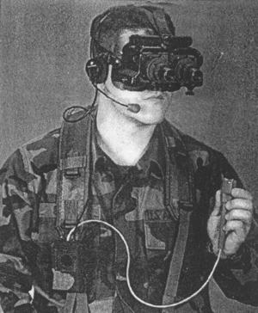
Photo 6. The appearance of night vision goggles with built-in communication system
The disadvantages of binocular glasses is their relatively large mass and cost. The latter is mainly determined by IC. In connection with this widespread the single II Tube night-vision goggles. [6] They contain one lens, one image intensifier, the image on the screen is diluted with the ocular system to the two eyes (photo 7, Fig. 9). Table. 3 shows the basic parameters of typical single II Tube night vision goggles. Their low weight and the presence of the lens makes it easy to convert points into the night with the help of binoculars removable telescopic lens attachment Galileo (photo 8). Due to an increase in the nozzle unit increases from 1 to 3 - 5 h depending on the increase in the nozzle [6]. Accordingly, the 1.5 - 2 times the range of the device increases. However, its field of view at the same time decreases so many times, how many times increased magnification.
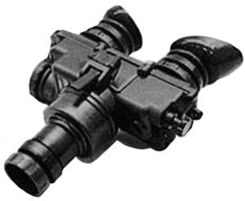
Photo 7. The appearance of typical single II Tube night vision goggles
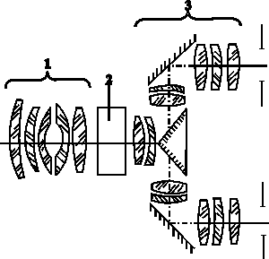
Fig. 9. The optical scheme single II Tube night vision goggles, where 1 - the lens 2 - GO, 3 - ocular system
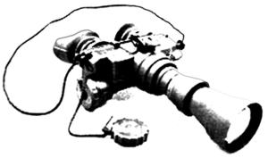
Photo 8. Appearance Single II Tube night vision goggles with telescopic nozzle
Table 3. Main parameters typical single II Tube night vision goggles
A common shortcoming of most common traditional glasses are their considerable longitudinal dimensions. Because of them, there is a large tilting moment. It creates a strain on the neck and facial muscles of the operator, causing it to fatigue. Therefore, the development effort aimed at creating a low-profile ("flat"), night vision goggles with minimal longitudinal dimensions. Typical of their representative is the unit GN-2 company Simrad (Norway) (Photo 9, Fig. 10) [21, 22] points Lucie company ANGENIEUX (France) [23, 24] (photo 10, fig. 11), points Clara [25] (photo 11) from Sfim (France) [25]. Driving low-profile points NV / G-14 Belomo (Belarus) [26] is built on the same principle as the glasses GN-2. The main parameters of low profile points are given in Table. 4. Distance from the first surface to the pupil of the eye glasses not exceeding 80 mm such devices, while for the conventional glasses size ranges from 135 to 200 mm. In the US, low profile sunglasses developed AN / GVS-21 [15]. Company Systems Research Laboratories (USA) has also developed a low-profile goggles Model 2777 [27] (Fig. 12). These glasses are made ​​of optical scheme of Fig. 5c on the basis of the third generation image intensifiers have the view angle 40 0. The same pattern is completed and points [28], built in on-head display pilot.
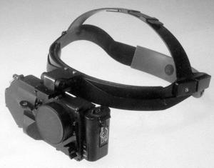
а)
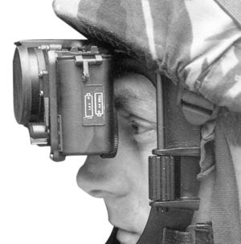
б)
Photo 9. The appearance of night-vision goggles GN-2 (a), their location on the head (b)
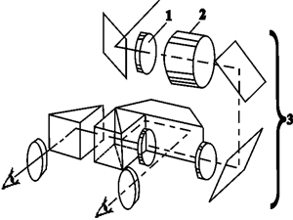
Fig. 10. Optical scheme NVG GN-2, where 1 - the lens 2 - GO, 3 - ocular system
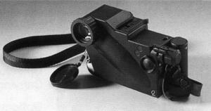
а)
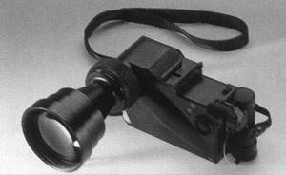
б)
Photo 10. The appearance of night-vision goggles Lucie (a), the same with telescopic nozzle (b)
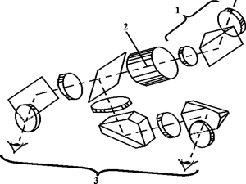
а)
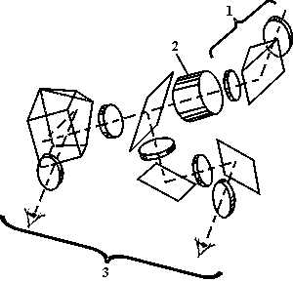
б)
Fig. 11. Possible optical circuits NVG Lucie (a, b), where 1 - the lens 2 - GO, 3 - ocular systemсистема
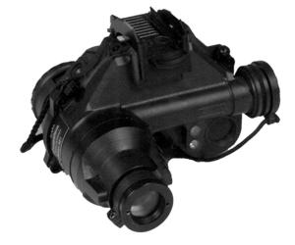
Photo 11. The appearance of night-vision goggles Clara
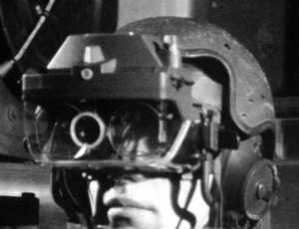
Fig. 12. The appearance of night-vision goggles Model M 2777
Table 4. The main parameters of low-profile night vision goggles
The company OIP (Belgium), and has also developed single II Tube "holographic" points HNV-1 [29] (photo 12). The principle of operation of the device is similar to the model HNV-3. Historically device HNV-1 appeared earlier than HNV-3.
Photo 12. The appearance of "holographic" NVG HNV-1
Night vision goggles can be used in conjunction with laser pointer mounted on the weapon and create a "dot" image illumination spots on the target [30] (photo 13). This sighting system can fire weapons from any position and in movement.
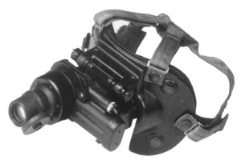
а)
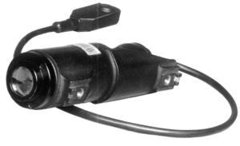
б)
Photo 13. Night sighting system: night vision goggles TN2-1 (a) and a laser designator PS1 (b)
A variety of night vision goggles are head-on night monoculars [1, 6] (photo 14). In essence, this is one night channel binocular glasses with battery performance and characteristic design for attachment to a face mask or a headband. Unified design monocular allows to use them as held in the hands of small night observation devices ("poketskopes"), join them with photo and video cameras for night shooting, be used as night sights for small arms. [6] The main parameters of the typical head-on monoculars are given in Table. 5
.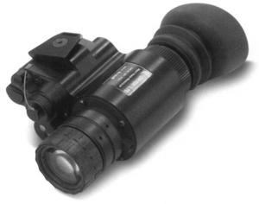
а)
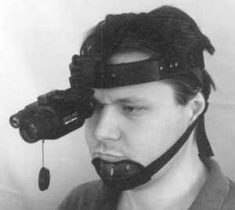
б)
Photo 14. The appearance of a typical night nagolovnym monocular (a) and its operating position (b)
Table 5. Basic parameters typical nagolovnym monoculars
All night-vision goggles and night vision monocular nagolovnym has built-in infrared LED, operating at a wavelength of 0.82 - 0.85 m with an angle of illumination 40 0 and used to illuminate the surrounding objects in order to stealth repairs, card reader and so on.
Advances in the field of high-sensitivity TV cameras based on CCD led to the development nagolovnym NTVS. They can be in two versions:
actual TV camera is on individual weapons, and the head of the operator - only small TV monitor ocular optics, fastening on the headband [32, 41];
All NTVS mounted on the head of the operator [33, 34].
An example of the first system is a device Argus-21 [32, 41]. Detection range of human growth figure in the starry night 350 m at an angle of sight 8 - 10 0 supply voltage of 12 V, the dimensions of the TV camera O40h160 mm and its weight of 1.5 kg, and the TV screen - 210h195h110 mm, respectively, and 0, 5 kg. Examples the second system can serve NTVS IHDTV (Intensified High Definition Television) company Bell Aerospase on Technology Corp. (USA) [33] and Kamera-Brille Typ 88,505 TV EMO-Electronik (Germany) [34]. IHDTV The device consists of a lens, a fourth-generation image intensifiers [5], to dock with TV camera based on CCD. Unit weight less than 900 g, a volume less than 0.5 l. The device comprises a gate, working with a strobe pulse width of 100 ns to 16.6 ms. It provides suppression of light interference. Device Kamera-Brille Typ 88,505 includes a TV camera, TV monitor and two eyepieces, focused on its screen. The device has a field of view angle 40 0, weight 500 g, the focus range of 0.1 m - infinite, beyond the base of the eye adjustment 60 - 72 mm outside the eyepiece diopter setting ± 5 diopters, powered by a separate battery voltage of 12 V DC, which provides 3 - 4 hours of continuous operation.
With the establishment of an effective focal plane microbolometer arrays operating without cooling in the range of 8 - 12 mm [35] there was a possibility of developing a thermal imaging device nagolovnym Helmetcam [36] (Fig. 13). It is used for the police and intelligence services, search for mines disguised ammunition hidden fires, damages in underground communications and so on. The device is based on the microbolometer focal plane array with a number of elements 320x240 operating in the spectral range 8 - 14 microns and having NETD  0.05 K at a frame rate of 30 Hz. The resolution of the device is 1.64 mrad field of view 30 0 (mountain.) X 22.5 0 (vert.), The mass of 2 kg, power consumption less than 10 watts, lifetime 13h10 3 hours. The display, made ​​by one eye of the operator, together with the attachment and e-strapping weighs 0.5 kg. It consumes less than 4 watts and delivers the brightness of the observed image 200 ft-L.
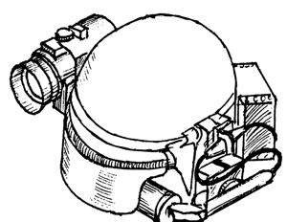
Fig. 13. Head-on thermal imaging device
Helmet combined device used to nagolovnym pilot system for nagolovnym equipment "soldier of the XXI century". Such a device may include goggles or night vision monocular, heating or TV device, a display for displaying the operational information from the navigation system of the aircraft or satellite GPS, sensor signals the laser irradiation.
In the simplest case, the night vision goggles to enter information screen of a cathode ray tube, which is also mounted on the pilot's helmet (Fig. 14a). Driving combine night vision goggles with TV system is shown in Fig. 14b. The system of Fig. 14b provides the input image from the screen to the image intensifier TV system and its subsequent remote transmission via radio. A specific example of such a system - the model NW-2000 by ITT (USA) [37]. The TV camera system is associated with one of the channels of the night night vision goggles for the pilot. Power TV camera requires a separate electronic unit with dimensions 15,24h12,7h5,72 mm consuming the source voltage of 12 V or 28 V DC current of 50 mA. TV camera format 1/2 inch has a resolution of 570 (mountains) h350 (V) TV lines, sensitivity up to 10 -3 lx in the signal / noise ratio greater than 50 dB. For versions of NW-2000T b NW-2000W respectively field of view is 18x24 0 and 26h34 0, 80 g and 105 g ​​Shutter TV camera operates with an exposure of 1/100 to 000 seconds. Model HUD (Head-up Display) company Elbit (Israel) introduces overhead in the night-vision goggles for the pilot scheme Fig. 13, only the plane mirror 2 rotated 90 0. Angle of view 32h24 0, the resolution of 512x512 pixels at light 10 -3 lx, weight 110g, power supply voltage 28 V DC. In the so-called "synthetic" night-vision goggles as shown in Fig. 15, one of the night channel points can be combined with a TV camera, and the other - with a TV monitor. This option is available in low-profile performance. In the picture 15 is given the appearance of such a system (model 100 ESIG) [40].
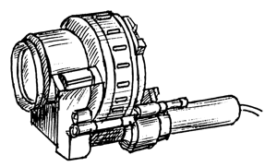
а)
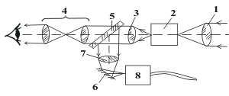
б)
Fig. 14. Appearance nagolovnym monocular (a), combined with a TV camera and optical scheme (b), where 1 - the lens 2 - GO, 3, 4 - ocular system, 5, 6 - mating plane mirrors 7 - Lens TV camera 8 - TV camera
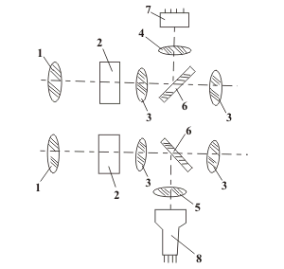
Fig. 15. The scheme of combining binocular night vision goggles with TV system, where 1 - the lens 2 - GO, 3 - ocular system, 4, 5 - lens TV cameras or TV monitor 6 - conjugating flat mirror 7 - TV Camera 8 - TV monitor
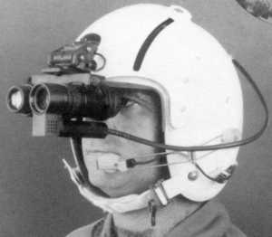
Photo 15. Appearance of aviation night vision goggles, combined with the TV system
In a more complex case, night vision goggles are part nagolovnym (helmet-mounted) display integral complex surveillance, piloting and aiming. Such displays embody the technology vision devices "Day / Night", which will be discussed in the next article.
Reference publications:
1. Volkov VG The current state of development of night vision devices. M. Review of number 5576, ch. 1.2, SEC Informtekhnika, 1994, 202 p.
2. Geikhman IL, Volkov VG Fundamentals of visibility in difficult conditions. MM Ltd. "Nedrabiznestsentr", 1999, 286 p.
3. Night vision devices. Brochures and Price List GUDP SKB TNV, the Russian Federation, Moscow, 2000.
4. Salikov VL Night vision devices: the history of generations .// Special equipment 2000, № 2, p. 40 - 48.
5. Volkov VG Night vision devices of new generations .// Special equipment 2001, number 5, p. 5 - 8.
6. Salikov VL The era of war .// Night Special equipment 2000, number 5, p. 21 - 32.
7. Night vision devices. Brochures FSUE "Alpha", Russia, M, 2002.
8. Night vision goggles for pilots GEO-ONV1. Prospect FPNTS NGO "Geophysics HB", the Russian Federation, Moscow, May 2002.
9. Cats Eyes. The Unique Aviators night Vision Goggle. Prospect firm GEC Avionics, UK, 1990.
10. Optical arragement. Patent number 0077193 UES, M.kl. 3 G02B 27/00, 17/00 with priority 20.04.83g.
11. Night Vision Goggle UK patent number 2100466, M.kl. 3 G02B 23/12, 23/10 with priority 29.05.81g.
12. Electron-safe aviators Ohno MVGS. Defense Electronics and Computing (Supplement to International Defence Review, 1990, No.2) p. 14.
13. Franck DL, Geiselman ee, Craig JL Panoramic Night Vision Goggle Flight Test Results. Proceedings of SPIE, 2000, Vol.4021, pp. 146 - 154.
14. Goodman GW Future Night Vision. Armed Forces Journal International, 2001, No.1, pp. 22, 24.
15. Hewish M. Image in everthing. Jane Ohno s International Defense News, 2002, Vol.35, No.5, pp. 28 - 25.
16. Mecham M. NASA, USAF Progress On Panoramic Goggles. Aviation Week and Spase Technology, 2000, Vol.153, No.7, p. 56.
17. 16-mm Image Intensifier. Prospect firm ITT, USA, 2000.
18. Night Vision Goggle. US patent number 5416315 with the priority from 16.05.95g.
19. Holographic Night Vision Goggles HNV-3D. Prospect of company OIP, Belgium, in 2000.
20. Laser secures troop communication. Laser Focus World, 1996, Vol. 32, No.9, p. 32.
21. Night Vision Goggles GN-1, GN-2. Prospect of company Simrad Optronics, Norway, 1999.
22. Image Intensifier Binocular. UES Patent № W087 / 00639, M.kl. 4 G02V 23/12 with priority 19.07.85g.
23. Night Vision Goggles Lucie. Prospect of company ANGENIEUX SA, France, 1999.
24. Jumelle compacte de vision nocturne. French patent number 2721719, M.kl. 6 G02B 23/12, 23/02 with priority 28.06.94g.
25. Night Vision Goggle CLARA. Prospect of company Sfim, France, 1999.
26. Night vision goggles NV / G-14. Optical devices and equipment. Product White. The Republic of Belarus, Minsk, 2002.
27. World Ohno s First NVG Jumps. Armada International, 1994, Vol.18, No.3, p. 33.
28. Helmet assesed for special forces. Jane Ohno s Defence Weecly, 1994, Vol.21, No.12, p. 22.
29. Holographic Night Vision Goggles HNV-1. Prospect of company OIP, Belgium, in 2000.
30. Sopelem TN-2 Night Vision Binoculars. Prospect of company Sopelem, France, 1998.
31. Low Profile Night Vision Goggle AN / AVS-502. Prospect of company Litton, United States, 1999.
32. Volkov VG Small television systems. Review number 5591, SEC Informtekhnika M., 2000, 157 p.
33. Osterkamp JB Enabling technologies in helmet-mounted intensifed cameras. Proceedings of SPIE, 2000, Vol. 4021, pp. 163 - 169.
34. Kamera-Brille Typ 88505TV. Prospect of the company EMO-Elektronik, Germany, 1999.
35. Volkov VG, Kovalev AP, Fedchishin VG Thermal imaging devices of new generation .// Special equipment 2001, number 6, p. 16 - 20, 2002, number 1, p. 18 - 26.
36. Miller JL, Duvoisin H., Wiltsey G. Applications and performance of an uncooled infrared helmetcam. Proceedings of SPIE, Vol. 3436, 1998, pp. 566-571.
37. NW-2000 Night Vision Camera System. Prospect firm ITT, USA, 1999.
38. Haixian Z. Synthesized night vision goggle. Proceedings of SPIE, 2000, Vol. 4021, pp. 171-177.
39. Elbit Ohno s Night Vision Head-Up Display. Prospect firm Elbit Computers Ltd., Israel, 1999.
40. Nur Fliegen ist schoner. Soldat und Technic, 1994, No.7, s. 387.
41. Volkov VG Technology scopes "day-night" Special equipment .// 2001, № 4, p. 2 - 7.

