LRM2000
LASER RANGE AND
SPEED DETECTOR MONOCULAR

Operation Manual

LRM2000 Laser Range and Speed Detector Monocular
Operation Manual
1. Introduction
Laser range and speed detector monocular is a portable optoelectronic device integrating functions of a monocular, laser range finder and speed detector. With great clearness of view, it can measure the distance of stationary or slow moving objects within certain range. It also can measure the speed of fast moving objects. The results can be stored. It has many advantages such as high accuracy, short measuring time, low power consumption and automatic shutdown for power protection etc. It is compact, light in weight and easily carried about.
Laser range and speed detector monocular is widely used for travel, sightseeing, hunting, camping, and hiking etc. It can be a very good assistant to improve our outdoor life quality.

2. Appearance

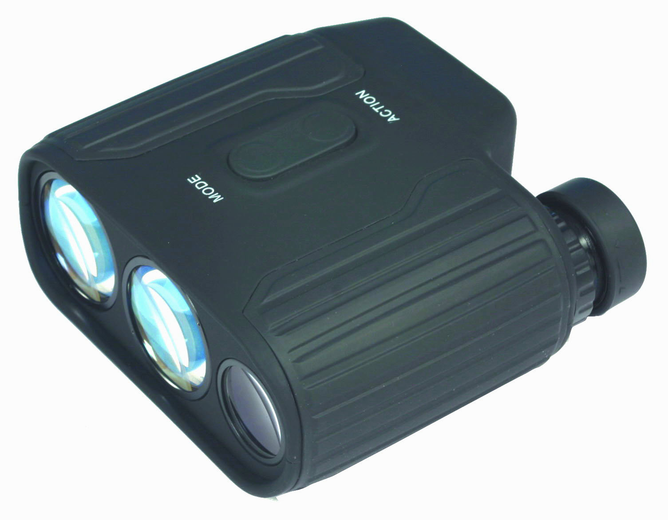
5
6

7
1
3
4
2

Figure 1. Laser Range and Speed Detector Monocular
1---Eyepiece
2--- Object Lens
3--- Laser Emitting Lens
4--- Laser Receiver Lens
5--- Mode Button
6--- Action Button
7--- Battery Compartment

3. Specifications
Distance Measure Range | 5～700M/2000M
Speed Measure Range | 0-300KM/H
Laser Type | 905nm
Object Lens Size | 25mm
Magnification | 8X
Field of View | 8.13°
Exit Pupil Diameter | 3.1mm
Diopter Adjust Range | ±6
Operation Temperature | -20～50°C
Distance Measure Time | Less than 4s
Distance Measure Accuracy | +/-1 M（Y）+/-0.2％
Speed Measure Time | Less than 3s
Speed Measure Accuracy | +/- 5 KM/H
Tripod Thread | 1/4″X20
Battery | 6F22-9V
Low Battery indicator | 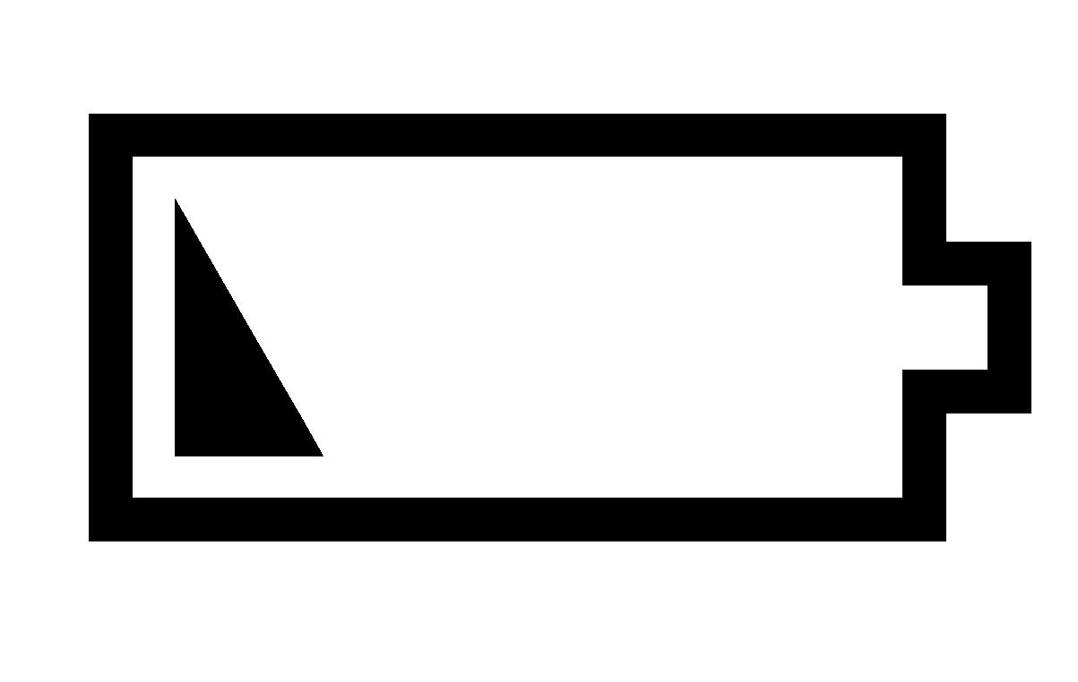
Net Weight | 472g
Dimensions | 121mmx127mmx58mm

4. Built-in LCD Displays
4.1 Explanation of LCD Diplays

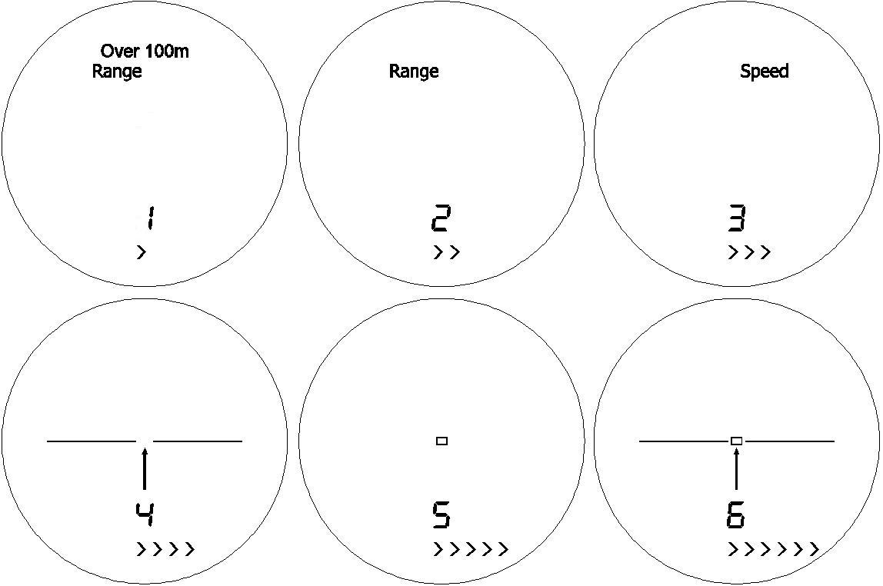

Figure 2. Built-in LCD Display
1) Pictures 1~3 are mode selection displays
a) Picture 1: Range > 100M mode, for long-range targets
b) Picture 2: Range >20M mode, for short-range targets
c) Picture 3: Speed detector mode; It requires aiming at the moving targets all the time so as to acquire the data. A target necessarily moves in a range between 50m to 500m. The measuring direction needs to be as in line with the direction of moving targets as possible; otherwise the angle will influence accuracy of results.
2) Pictures 4~6 are three different reticule indicator used for aiming the target.
When the LCD is on, shortly press the “Mode” button you can select the above 6 modes in turn.
4.2 LCD Indicators
1) “Ready”— The range finder or speed detector is ready.
“Range”— Range finder mode.
“Speed”— Speed detector mode.
When “ACTION” button is pressed for 2 second, the device starts and “Ready” will appear. Rangefinder is functioning when “Range” appears; and speed detector is functioning when “Speed” appears,
2) “ ”—Aiming indicator（in Figure 2, pictures 4~6 are all aiming indicators， and users can choose anyone of them ）
3) “”—Distance display in 4 figures. “----” appears when measurement fails.
4）“M”, “Y”— Length measure units, “M” stands for meters and “Y” stands for yards. Units can switch to each other by long pressing “MODE” button.
5） “KM/h” ，“M/S”—Speed measurement units, “KM/h” stands for kilometer per hour and “M/S” stands for meter per second. Units can switch to each other by long pressing “MODE” button. If measurement is unsuccessful then four dashes, “----” appears.
6） “Over 100M” — Distance measuring mode indicator. When “OVER 100M” displays, the distance of targets is further than 100M. It is recommended to measure small targets in closer distance, and for longer-distance targets.
7） “QUALITY＞＞＞＞＞＞”— Indicator of laser reflection quality. The more “＞”stands, the stronger reflection. In general, rangefinder needs at least three “＞”; otherwise, it’s not good for measuring distance。
8）“”— Laser transmission indicator. It will flash when laser is transmitting。
9）“ ”— Low battery indicator .When “ ” displays，please change the battery.

5. Operation Instruction
5.1 Firstly, turn the diopter of eyepiece until the image becomes clear.
5.2 Press “ACTION” button for 2 seconds, and the rangefinder will start. The LCD will display the chosen mode last time. Press “Mode” button, the LCD will displays picture 1, picture 2 and picture 3 in Figure 2, and choose one you need.
a) Picture 1: >100M mode, used for long-distance targets. Press “ACTION” button to select picture 1. “OVER 100M” and “Range” will display in LCD. Aim at the targets, and press “ACTION” button to acquire the distance data, which is shown immediately. If laser reflection is too weak, “----” will display in 4 seconds. The distance data will be kept before next measurement. The device will automatically power off if there is no operation in 30 seconds.
b) Picture 2: >20m Mode, used for short-distance target. Press “ACTION” button to select picture 2. Only “Range” shows in the LCD. Operation is the same as above.
c) Picture 3: Speed mode. “Speed” appears in the LCD. Aim at targets, and press “ACTION” button to start detecting. “” flashes when the laser is transmitting. The speed data will display in LCD. There are two ways to measure the speed. One is the forward speed measurement. When target moves toward users, users aim at the center of the targets, and press “ACTION” button. The other one is backward speed measurement. When targets move against users, users aim at the center of targets’ back and press “ACTION” button. The speed data will display in 3 seconds. If the measurement fails, “----” displays. Please keep the minimum angle during the speed detecting (under the premises of safety) to minimize the error of results. Long press the “MODE” button to switch the speed measure units between “KM/H” and “M/S” in mode of the speed measure. When the speed measure unit is “M/S”, left two digits of four numbers are whole number of the speed data, the third is a radix point shown as “-”, and the fourth digit is decimal. For example, 12.8m/s will shows as 12-8M/S in the LCD..
5.3 User can choose one of three aiming reticules as in pictures 4、5、6 in Figure 2 according to characters of targets. Press “MODE” button, and the LCD will display three aiming reticules in turn. When you decide one, please press “ACTION” button to confirm and the symbol will not flash any longer.
5.4 When pressing “ACTION” button, laser can’t transmit. After releasing “ACTION” button, measurements of range or speed starts. Please don’t press “ACTION” button for over 2 seconds, or it becomes long pressing.
5.5 The results of last 10 measurements will be saved automatically. Long presses “ACTION” button for 2 seconds, the LCD displays “code”. The sequence number (1-10) will appear, and then the data of last ten measurements. Upon pressing the “ACTION” button, the display will sequentially show the results of last 10 measurements, starting from latest one. Upon pressing the “MODE” button, it will exit.

6. Problems and Troubleshooting
Laser rangefinder and speed detector monocular is a complicated optoelectronic product. Usually, when devices have problems, they need to be sent to professional repair shop. However, sometimes, some general problems are caused by improper operation as following:
1) Failure of “MODE” selection:
a) “ACTION” button was not pressed in time while one of the pictures is flashing;
b) Low battery.
2) No display of data:
a) Choosing “OVER 100M” mode for targets within 100M;
b) The laser reflection is too weak due to long distance, or bad weather;
c) Fingers block either laser transmission lens or receiver lens while operating.
d) Hands shake too much during the operation and aiming center is not pointed to the target.
e) Low battery.
3) Changing results during operation:
a) Low battery;
b) Users point the device to the Sun or strong light during operation.

7. Cautions
7.1 The performance of the laser range and speed finder monocular has something to do with the target’s character, transmitting beams with the angle of the target’s surface and the weather. In general, if the surface of the target is smooth, bright and large, the beams are upright to the surface of the target and the weather is clear, the longer distance can be measured, otherwise the shorter distance will be measured.
7.2 When “ ” (low battery indication) appears, please change the battery in time, or the measuring errors will increase. If the device will not be used for a long time, please take out the battery.
7.3 Never touch the surface of the lens so as to prevent the coating from damages.
7.4 This device has been accurately aligned and adjusted with highly precise equipments. Never disassemble it at random.
7.5 If the external lens is stained, please clean it with the lens cloth. Don’t use other things which may damage the lens coating.
7.6 Collision or high pressure should be avoided when carrying about or operating the device.
7.7 Keep the device at a dry, cool and airy place so as to prevent the corrosion. Avoid fire, dust, direct sunshine and extreme change of temperature.
7.8 If the device meets with problems, send it to a professional department, and never disassemble it by yourselves.

8. Accessories
Name | Quantity
Laser rangefinder and speed detector monocular | 1
Carrying case (shoulder belt included) | 1
Color box | 1
Neck strap | 1
Poly bag | 1
User manual | 1
Cleaning cloth | 1
Drier gel | 1

